Requirements to run script:

* Python 3.6
* Numpy installed
* A test folder containing 2 sub folders named pos and neg
* A train folder containing 2 sub folders named pos and neg

Spec used to test:

* Windows 10
* Python 3.6.3
* Numpy 1.14.0

User guide:

Once the application is launched through the terminal you will be prompted with the limited menu which shows available options. The menus will also point out that the training and test data is not loaded. To continue in the application a model needs to be trained or imported from training data. Pressing 1 will generate a new model from a test folder that contains reviews sorted in 2 folders named pos and neg. This process takes a few minutes. The second option is to import an already generated training model. There should be one with the module already. This process is instant compared to generating a new one.

Option 3 is also available from the start menu to load your test data, this won’t effect nor do anything until a model is trained or loaded.

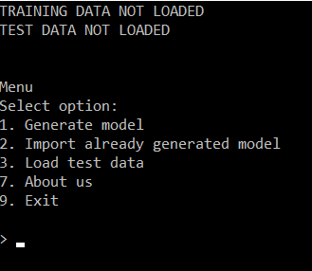

This is the windows you’ll see when generating a new model, the longest process about this is loading all the txt files.

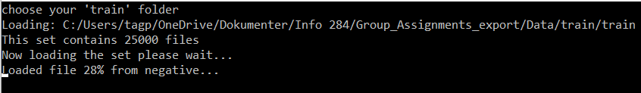

Now that the model is trained all other options open up in the menus. You will also see the top test has changed to “TRAINING DATA LOADED” to confirm that it did indeed work. From this stage on any option may be selected except 4. Score with loaded test. This option will tell you to load the test data first through option 3. Once the test data is loaded from option 3 option 4 will also be available.

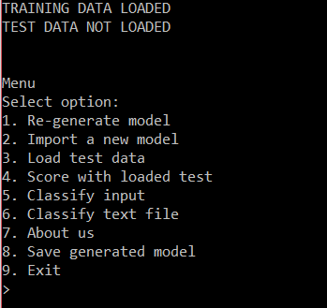

Loading test data also takes a few seconds because of the IO operations. How ever it is a lot faster than generating the model

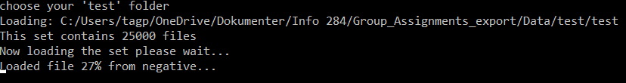

When test data finished loading it will be displayed at the top like the training data.

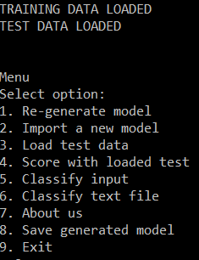

Option 4, selecting this option will run the model on all test data loaded and return an accuracy, precision and recall of the model

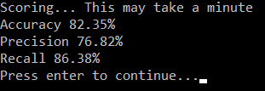

Option 5, once selected you will be asked to write a review to be classified, this review is submitted by pressing enter.



Option 6, this option opens a file selection window that lets you select a .txt file to be classified by the model.

Option 7, prints a small message containing out candidate numbers

Option 8, this saves the currently loaded training model. Note: It overrides the old saved model.

Option 9, terminates the application